**CA2020 Software Developer Bootcamp**

Farhana Akter

Virginia, USA



**Assignment 3**

**20 May, 2020**

**Introduction Version Control System (Git)**

* Practice on the following commands:
  + Git clone
  + Git init
  + Git diff
  + Git status
  + Git add .  & Git add filename
  + Git log
  + Git commit -m “message here”
  + Git push
  + Git pull
  + Git reset
  + Git config --global username “usernamehere”
  + Git config --global user.email “emailhere”

[Cloning a repository using the command line](https://help.github.com/en/github/creating-cloning-and-archiving-repositories/cloning-a-repository#cloning-a-repository-using-the-command-line)

1. On GitHub, we need navigate to the main page of the repository.
2. Under the repository name, we’ll click Clone or download.  
   lone or download button
3. To clone the repository using HTTPS, under "Clone with HTTPS", click . To clone the repository using an SSH key, including a certificate issued by our organization's SSH certificate authority, click Use SSH, then click .  
   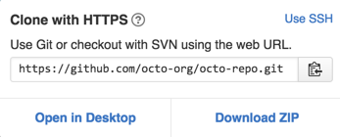
4. We’ll open Terminal.
5. We’ll change the current working directory to the location where we want the cloned directory.
6. We’ll type git clone, and then paste the URL we copied earlier.  
   $ git clone https://github.com/*YOUR-USERNAME*/*YOUR-REPOSITORY*

We’ll press “enter” to create our local clone.  
$ git clone https://github.com/*YOUR-USERNAME*/*YOUR-REPOSITORY*

> Cloning into `Spoon-Knife`...

> remote: Counting objects: 10, done.

> remote: Compressing objects: 100% (8/8), done.

> remove: Total 10 (delta 1), reused 10 (delta 1)

1. > Unpacking objects: 100% (10/10), done.

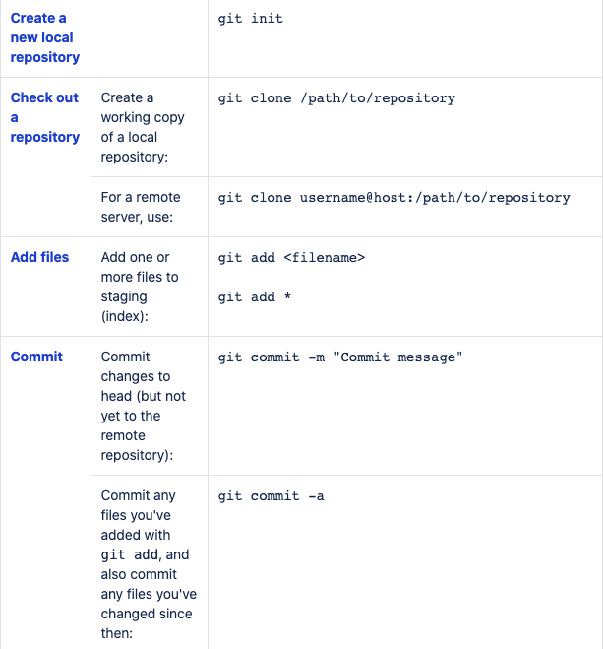

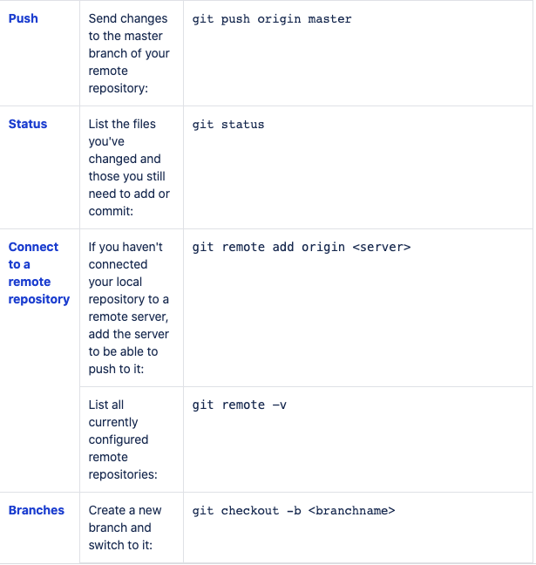

**TASK 02:**

* Create an account on GitHub.
* Create a repository with the name “BOOTCAMP_CA2020”.
* Make sure to create this repo with README.md file where you can write necessary information of what this repo is all about.
* Kindly, push both of your assignments as a separate file of each day.

**NOTE:** Files that you have created on Google Doc please download that as a doc file (Separate day1 and day2 task in individual file) and push them on git.

* Learn the concepts of Branching and Merging and create a doc on it. Push the same doc on Git as a separate file named it as day3_task.txt.

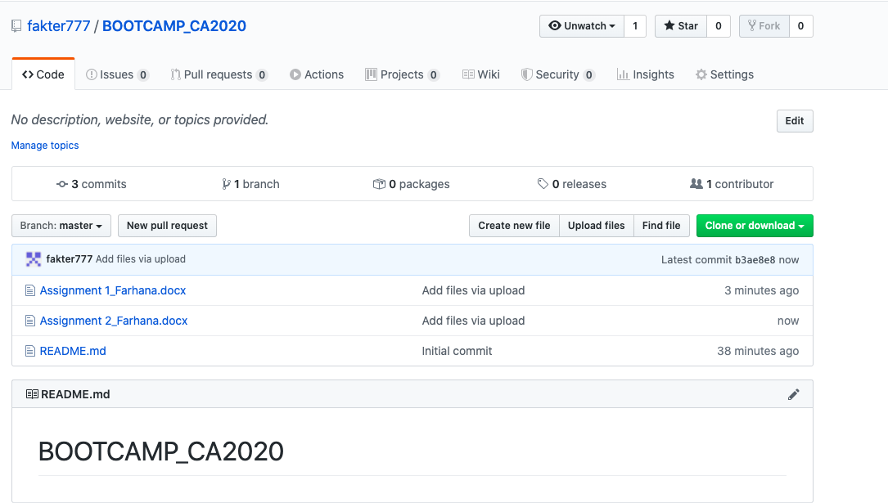

**TASK 03:**

* **What is Elastic IP and how it is different from Dynamic IP?**

An Elastic IP address is a public IPv4 address, which is reachable from the internet. Elastic IP addresses are used by AWS to manage its dynamic cloud computing services. When a device is assigned an elastic IP address, the address does not change. But a dynamic IP address is an IP address that changes from time to time.

* **What is the Client Server Model, Explain in detail?**

The client-server model is a core network computing concept also building functionality for email exchange and Web/database access. Web technologies and protocols built around the client-server model are: HTTP, DNS etc. A server manages most processes and stores all data. Clients include Web browsers, chat applications, and email software, among others. Servers include Web, database, application, chat and email, etc. A client requests specified data or processes. The server relays process output to the client. Clients sometimes handle processing, but require server data resources for completion.

Reference

<https://confluence.atlassian.com/bitbucketserver/basic-git-commands-776639767.html>